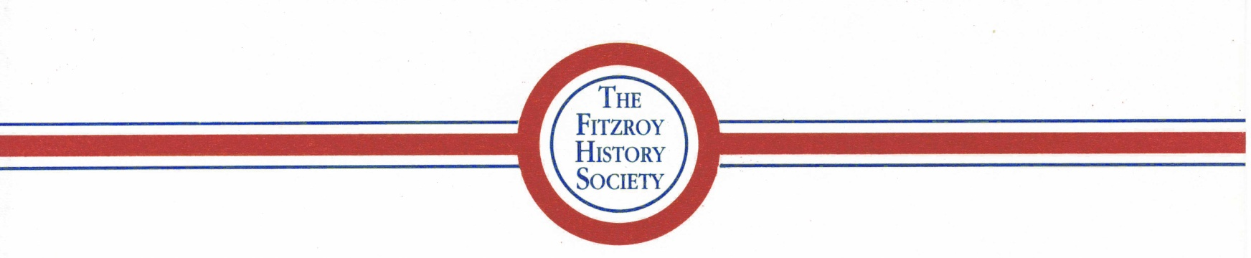

FHS MEMBERSHIP RENEWAL / MEMBERSHIP APPLICATION – (Renewals due annually on July 1)

Name ________________________________________________________________
Member information (if different from last year)
Address ______________________________________________________________
Mobile/Phone ________________________________
Email (please print) ________________________________________
Date __________

Subscription to Fitzroy History Society FHS is now $20 per person, per year, renewable annually on July 1.

Newsletters (in a print ready format) will be sent via email only, unless you specifically request postage.

Payment options
Our preferred option for payment to ease administration, lower cost and simplify record keeping is #1.
1. Paying by Direct Transfer to Bendigo Bank: BSB No: 633000 Account No: 151620127 Account Name – Fitzroy History Society Inc.
*** Please make sure the message/reference box states your name and what the payment is for.
***If you are a new member or updating member information we would appreciate the return of your completed form by mail or by email.

2. Paying by Cheque/Cash, please make the cheque payable to the Fitzroy History Society. Kindly forward your cheque/cash and completed form to the FHS, PO Box 180, Fitzroy, 3065.

I would like to assist with:
( )Committee and administration ( )Newsletter ( )Walks ( )Talks ( ) Other (please specify)

My interest in Fitzroy’s history is ________________________________________________
___________________________________________________________________________
___________________________________________________________________________

and I can contribute the following information / knowledge on Fitzroy History _______________________
________________________________________________________________________________________
________________________________________________________________________________________

I apply to renew my membership / join the Fitzroy History Society Inc. I support the purposes of FHS and agree to comply with the Model Rules of Association.

Signed: …………………………………………………………………………

Find out more : FHS website https://fitzroyhistorysociety.org.au
FHS Facebook page https://www.facebook.com/fitzroyhistorysoc
FHS Email - fitzroyhistorysociety@yahoo.com.au

