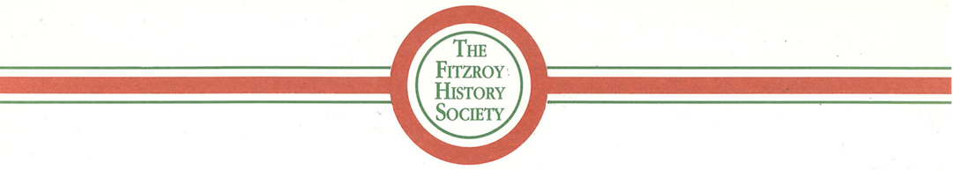
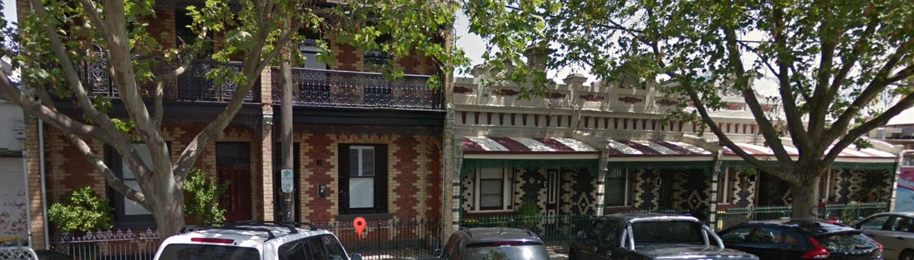

Researching Your House in Fitzroy

using the resources of the Fitzroy Library and the Internet

Recommended sequence for researching

1 Build up a database of early occupants, from the Sands & McDougall directories
- of your house, your neighbours, and maybe the whole block of your street
- noting any changes of house numbering that may have occurred in 1905, 1888, and 1865

2 Rate books give details on occupants and their occupations, the owner, building description, valuation
- if you already know the resident's name, use Ancestry.com.au
- use Fitzroy rate books from 1859 onwards, and the Melbourne rate books prior to 1858

3 For the original building date, building material, owner, builder, it is possible to search
- Burchett Index (2423 early records of Fitzroy over the period 1850 to 1870)

4 Some one-time records and indexes across Fitzroy, and held at the Fitzroy Library, are
- VPRS:3182 MCC List of Improved & Unimproved Property, Fitzroy Ward, Nov 1854
- Index of petitioners for municipal separations, from 1856 to 1863
- MMBW detailed maps of Fitzroy, 1897 to 1900 (also available on-line from SLV)

5 Information on owners, occupants and their families is available in
- index of births, marriages, deaths, inquests
- shipping arrivals http://prov.vic.gov.au/index_search?searchid=23
- wills and probate records http://prov.vic.gov.au/index_search?searchid=54

6 Newspaper searching
- http://trove.nla.gov.au/ndp/del/search?adv=y

7 Internet searching
- http://www.google.com.au/advanced_search?hl=en

Resources in the Fitzroy Library

A Melbourne & Suburban Directories (by Sands & McDougall, Sands & Kenny, Tanner, etc)
1839 to 1974 on microfiche
1854, 1859, 1860-81, 1884, 1892, 1893, 1904, fully searchable on CDs

B Rate Books Fitzroy 1859 to 1949 (on microfilm) and 1958 to 1973 card index (on computer)
Melbourne 1845-60 rate books, and 1843-50 property valuations (on microfiche)
MCC List of Properties, Fitzroy Ward, 1854

C MMBW (Melbourne and Metropolitan Board of Works) maps of 1897-1900 period,
showing outline of individual houses in Fitzroy (also on-line at slv.vic.gov.au)

D Municipal Petitions Index (1856-63), includes 6,600 petitioners names and addresses from Fitzroy

E Burchett Index of "Notice of intention to build", 1850-70 (on CD & FHS website)

F Index of Births (1836-1920), Marriages (1836-1942), Deaths (1836-1985) Also on Ancestry.com.au

G Victorian Government Gazette gazette.slv.vic.gov.au - but with a limited index
or a fully searchable version on the Fitzroy Library "local history" computer, for 1847 and all years 1851-1897

H City of Yarra Heritage Studies 1978 to 1998 (in bookshelves)
and Heritage Database 2008 on "local history" computer
~~~~~~~~~~~~~~~~~~~~~~~~~~~~~~~~~~~~~~~~~~~~~~~~~~~~~~~~~~~~~~~~~~~~~~~~~~~~~~~~~~~~~~~~~

Resources on the Internet

Newspapers
Trove archive at National Library of Aust. http://trove.nla.gov.au/ndp/del/search?adv=y
Port Phillip Herald 85,000 pages, from 1840 to 1902 paperofrecord.com

Ancestry.com.au (either by personal subscription, or free use at the Fitzroy Library)
City Directories, 1860-1942 http://search.ancestry.com.au/search/db.aspx?dbid=60845
Fitzroy Rate Books, 1858 to 1900 http://search.ancestry.com.au/search/db.aspx?dbid=60706
Electoral Rolls, 1903-1980 http://search.ancestry.com.au/search/db.aspx?dbid=1207

City of Yarra at yarracity.vic.gov.au
then select > Planning > Heritage or > Libraries > Local History Collection

Public Record Office Victoria > Online indexes and digitised records at prov.vic.gov.au
select > Wills and Probate often describes properties and contents
or > Passenger Lists often includes early immigrants to Fitzroy

Pictures
National Library of Australia (Trove) picture archive at trove.nla.gov.au/picture
University of Melbourne Archives at http://archives.unimelb.edu.au/ - especially the 300+ Fitzroy photos in the John L O'Brien collection, readily located using
http://gallery.its.unimelb.edu.au/umblumaic/imu.php?request=search

