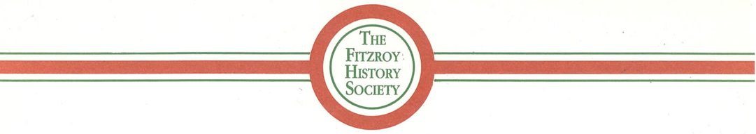
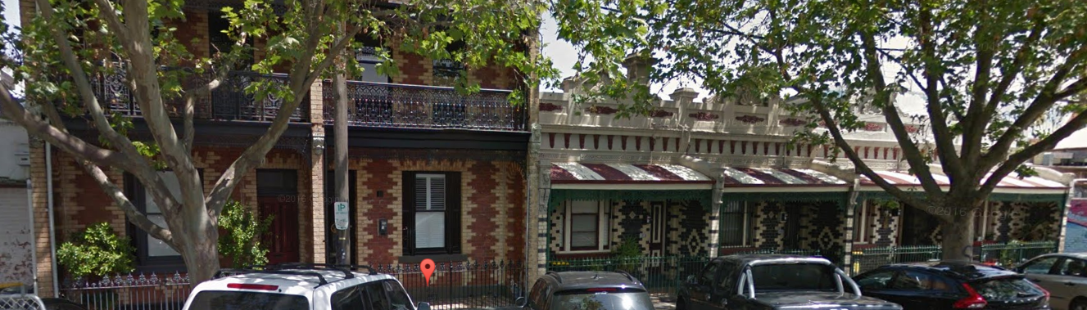

Researching Your House in Fitzroy

using the resources of the Fitzroy Library and the Internet

Recommended sequence for researching

1 Build up a database of early occupants, from the Sands & McDougall Directories
- of your house, your neighbours, and maybe the whole block of your street
- noting changes of house numbering that occurred in 1905, 1888, and 1865

2 Rate books
- details on occupants and their occupations, owner, building description, valuation
- if you already know the resident's name, use Ancestry.com.au
- use Fitzroy rate books from 1859 onwards, and the Melbourne rate books prior to 1858

3 For the original building date, building material, owner, builder, it is possible to search
- Burchett Index - (2423 early records of Fitzroy over the period 1850 to 1870)

4 Some one-time records and indexes across Fitzroy, and held at the Fitzroy Library, are
- VPRS:3182 - MCC List of Improved & Unimproved Property, Fitzroy Ward, Nov 1854
- Index of petitioners for municipal separations, from 1856 to 1863
- MMBW detailed maps of Fitzroy, 1897 to 1900 (also available on-line at State Library of Victoria)

5 Information on owners, occupants and their families is available in
- index of births, marriages, deaths, inquests
- shipping arrivals https://www.ancestry.com.au/search/collections/1635/
- wills and probates
https://prov.vic.gov.au/explore-collection/explore-topic/wills-and-probates

6 Newspaper searching
- https://trove.nla.gov.au/search/advanced/category/newspapers

Resources in the Fitzroy Library

A Sands & McDougall Melbourne & Suburban Directories
1839 to 1974 on microfiche
1854, 1859, 1860-81, 1884, 1892, 1893, 1904, fully searchable on CDs

B Rate Books
Fitzroy, 1859 to 1949 (on microfilm) and 1958 to 1973 card index (on computer)
Fitzroy 1858-1900 on-line at https://www.ancestry.com.au/search/collections/60706/
MCC 1845-60 rate books and 1843-50 property valuations (on microfiche).
MCC List of Properties, Fitzroy Ward, 1854.

C MMBW (Melbourne and Metropolitan Board of Works) plans of 1897-1900 period,
showing outline of individual houses in Fitzroy
(also on-line at slv.vic.gov.au)

D Municipal Petitions Index (1856-63), on CD
includes 6,600 petitioners’ names and addresses from Fitzroy

E Burchett Index of "Notice of intention to build",1850-70
on CD, and on-line at website of Fitzroy History Society

F Births (1836-1920), Marriages (1836-1942), Deaths (1836-1985)
at ancestry.com.au as detailed below or
Births, Deaths & Marriages Victoria https://www.bdm.vic.gov.au/

G Victorian Government Gazette
1836-1997 is at gazette.slv.vic.gov.au - but with a limited index
For 1847 and 1851-1897, a fully searchable version on the "local history" computer,

H City of Yarra Heritage Studies
1978 to 1998 loan copies and reference available
Also available online from the City of Yarra Heritage page
https://www.yarracity.vic.gov.au/the-area/heritage
or the direct link to the Heritage Studies
https://www.yarracity.vic.gov.au/the-area/heritage/heritage-studies

Resources on the Internet

A Newspapers
Trove archive at NLA https://trove.nla.gov.au/search/advanced/category/newspapers
Port Phillip Herald 85,000 pages, from 1840 to 1902 paperofrecord.com

B Ancestry.com.au (either by personal subscription, or free use via the Fitzroy Library)
City Directories, 1860-1942 http://search.ancestry.com.au/search/db.aspx?dbid=60845
Fitzroy Rate Books, 1858-1900 https://www.ancestry.com.au/search/collections/60706/
Electoral Rolls, 1903-1980 https://www.ancestry.com.au/search/collections/1207/
Birth Index (Vic) 1837-1917 https://www.ancestry.com.au/search/collections/61648/
Marriage Index (Vic) 1837-1950 https://www.ancestry.com.au/search/collections/61649/
Death Index (Vic) 1836-1988 https://www.ancestry.com.au/search/collections/61650/
Passenger Lists (Vic) 1839-1923 https://www.ancestry.com.au/search/collections/1635/

C Public Record Office Victoria at prov.vic.gov.au
For Wills and Probate - often describes properties and their contents
https://prov.vic.gov.au/explore-collection/explore-topic/wills-and-probates
For Passenger records and immigration - often includes early immigrants to Fitzroy
now only available via ancestry.com.au as detailed above

D State Library of Victoria
Melbourne Directories 1860-1974 - but only at 5 yearly intervals
http://cedric.slv.vic.gov.au/R?RN=505624056

E Pictures
National Library of Australia (Trove) picture archive at trove.nla.gov.au/picture
State Library of Victoria https://www.slv.vic.gov.au/
Fitzroy and other public libraries http://www.picturevictoria.vic.gov.au/
University of Melbourne Archives at http://archives.unimelb.edu.au/
- especially the 300+ Fitzroy photos in the John Lockyer O'Brien collection,
located at http://gallery.its.unimelb.edu.au/umblumaic/imu.php?request=search
using the search term “ lockyer “

